DOCKER NETWORKING:

1. Create new Ubuntu VM and install docker on it.
2. Create the container for nginx:

docker run -d -P nginx:latest

1. Docker inspect cont_id: to view the complete details on container

1. Networking types in Docker:
2. None- container doesn’t get any IP address.
3. Overlay- to connect two different containers present in two different nodes.
4. Bridge- will assign IP out of network pool of docker
5. Host- assigns node servers ip to containers.
6. Ipvlan- IPV$ and IPV6 / can manipulate ipv4 and ipv6 to your containers.
7. Macvlan- mac ID map with your container/physical server IP is mapped to container

1. Docket network ls: list all vpc’s in docker

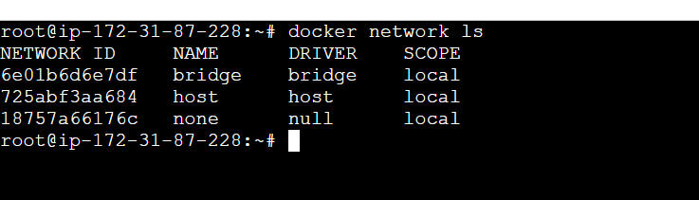

1. Creating VPC

docker network create --subnet "192.168.0.0/16" --driver bridge newnetwork

1. docker run -d -P --network newnetwork nginx : to assign subnet to the container



1. docker run -d -P --network host httpd : instance IP is assigned to the container

1. docker run -d -P --network none tomcat : Isolated network

1. docker network rm networkID: for deleting the network.(first need to stop and then delete it.)

